Models.
1. BCG ( Company )
A BCG matrix is a model used to analyze a business's products to aid with long-term strategic planning. The matrix helps companies identify new growth opportunities and decide how they should invest for the future. Most companies offer a wide variety of products, but some deliver greater returns than others.
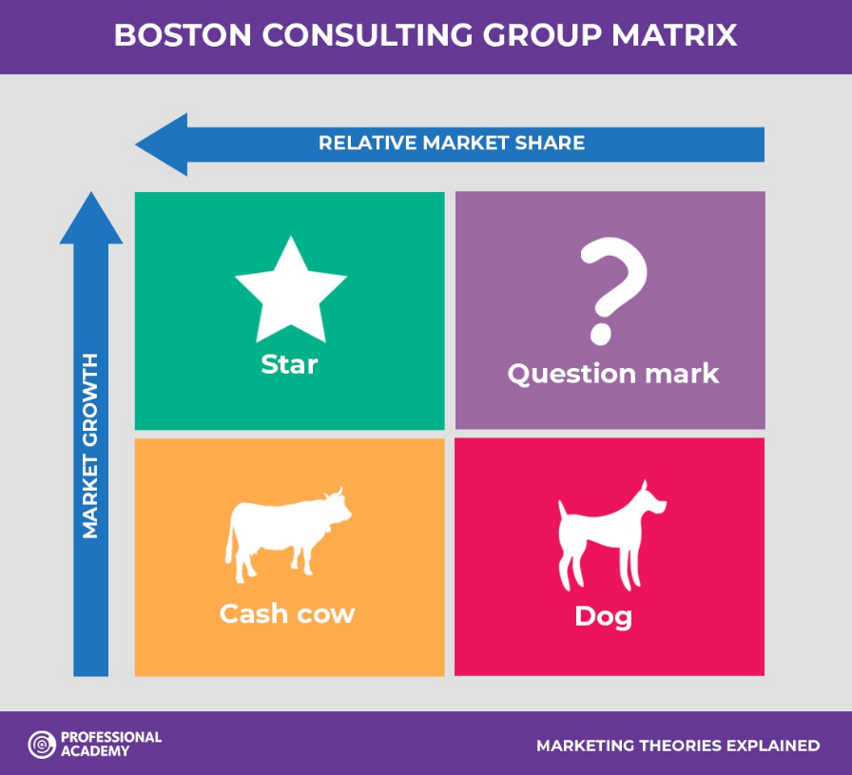

Low Growth, High Share. Companies should milk these “cash cows” for cash to reinvest elsewhere.
High Growth, High Share. Companies should significantly invest in these “stars” as they have high future potential.
High Growth, Low Share. Companies should invest in or discard these “question marks,” depending on their chances of becoming stars.
Low Share, Low Growth. Companies should liquidate, divest, or reposition these “pets.”

2. Ansoff matrix ( Company )
helps marketers identify opportunities to grow revenue for a business through developing new products and services or "tapping into" new markets. So it's sometimes known as the 'Product-Market Matrix'

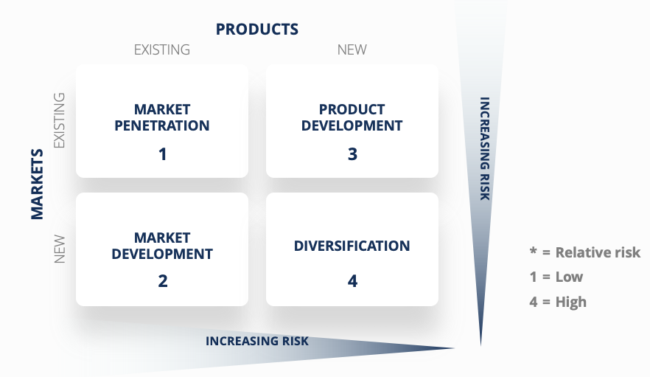

- Market Penetration – The concept of increasing sales of existing products into an existing market
- Market Development – Focuses on selling existing products into new markets
- Product Development – Focuses on introducing new products to an existing market
- Diversification – The concept of entering a new market with altogether new products

Porters 5 forces model ( Industry )

Porter's five forces help to identify where power lies in a business situation. This is useful both in understanding the strength of an organisation's current competitive position, and the strength of a position that an organisation may look to move into.

Porter Generic Model
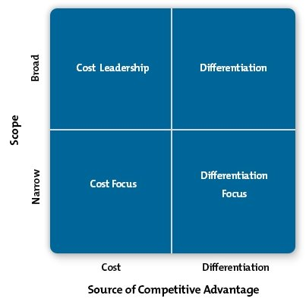

.

Personal selling process
1. Prospect and qualifying
2. Pre approach
3. Approach
4. Understand needs
5. Presentation and Demonstation
6. Objection handling
7. Close
8. Follow up and Service.

